NATIONAL UNIVERSITY OF MODERN LANGUAGE ISLAMABAD
Lab 05


Submitted to:
Ms. Saadia Shabbir
Submitted by:
Zulqarnain Hassan (SP21379)
Ehsan Mehmood (SP21371)
Mursal Malik
Subject: …………………… Web engineering
Department: ……………… BSSE-5-Afternoon
Date: ……………………… 26-10-2024

Task 01
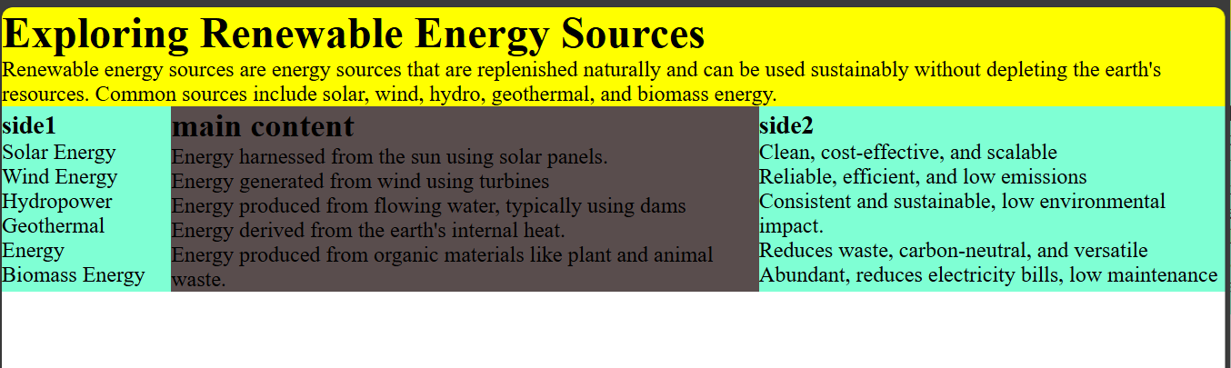

Task 02
